Use Case 1:

Creating a task

**Precondition**: user has updated version of app which is compatible with their OS

**Main flow**: User will create a task[a] and provide how important it views the task[b] and the due date[c]

**Subflows:**

1. User types in contents of task
2. User provides the a scale for how important the task is and app will insert it into task list appropriately
3. User provides the date when the task is due and the app will insert it into task list appropriately

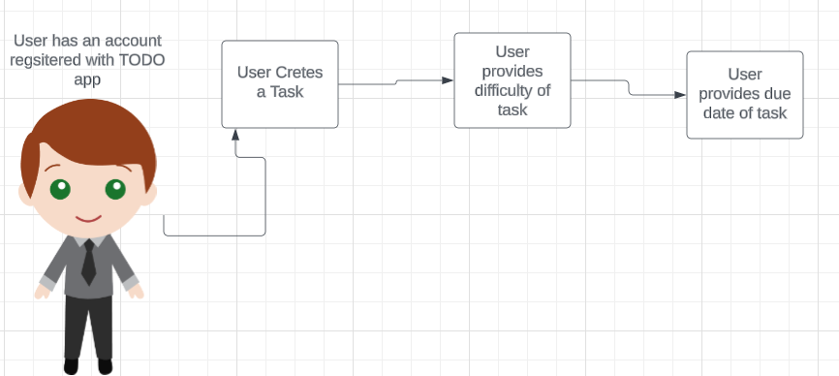

Use Case 2:

Finishing a task

**Precondition:** User has a task in the app which is not completed

**Main Flow:** User will navigate to the task list and find the task that they wish to mark as completed.[a] User will select the task and check the box labeled “DONE”. [b]

**Subflows:**

1. The task will enlarge and be the only task the user can see
2. A message will be displayed saying the user completed the task and it will be removed from the task list



Use Case 3:

Sorting a Task

**Precondition:** At least one task must be in the app already **Main Flow:** User will navigate to a section at the top of the app which will have a label that says “Sort By:”.[a] The user will navigate to the drop down menu next to the “Sort By:” label[b].

**Subflows:**

1. Sort by section will be highlighted when hovering over
2. User has the choice of sorting by: due date, priority, or alphabetical.

**Alternative Flow:** If user doesn’t select anything sort by date entered

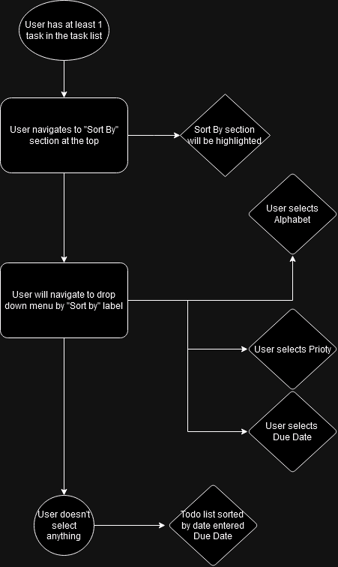

Use Case 4:

Changing deadline for task

**Precondition:** User wants to change the deadline for an already created task.

**Main Flow:** User will navigate to the already created taskand select the task[a]. The user will hit the box labeled “CHANGE DATE” [b]. Then the user will then select the new deadline[c].

**Subflows:**

1. Task will enlarge
2. A new window will open and it will show a calendar for the user to change the date.
3. After changing the date, the task will move to the selected date in upcoming tasks.



Use Case 5:

Adding another user to a task

**Precondition:** Both users have the TODO app downloaded and have accounts

**Main Flow:** User1 will create a task and fill out the necessary information including if any partners want to be added. [a]User1 will then type user 2’s username into the text box and it will add user2 to the task. [b]The task will then show up for both users.[c]

**Subflow:**

1. User will click on “create a task” button and a menu will appear for the user to fill out
2. As the user types, usernames that match what has been types so far will show up
3. Both users will be able to have access to the task and any modifications will show up in real time for both users

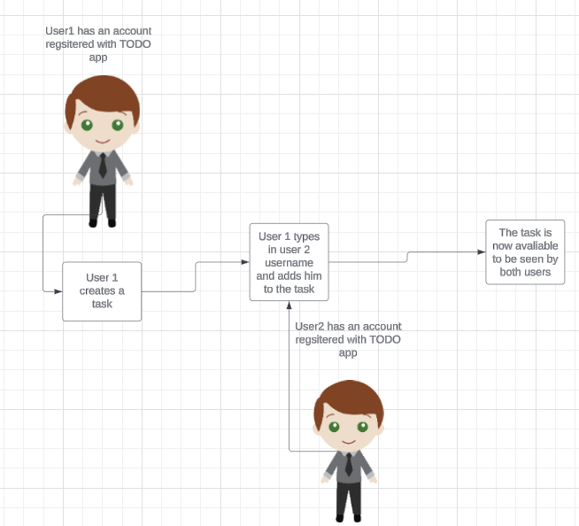

## Prototype App Layout

